### 1. Given the provided data, what are three conclusions we can draw about Kickstarter campaigns?

1. Based on the given data and as shown in the below graph, almost one third of the fundings are launched for theatre category (%34), and it is followed by music (%17) and technology (%15).

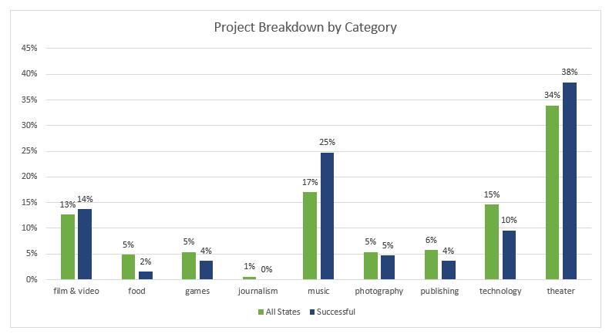

Even though the project count is two times lower compared to theatre, %77 of the projects initiated for music reached their goals.

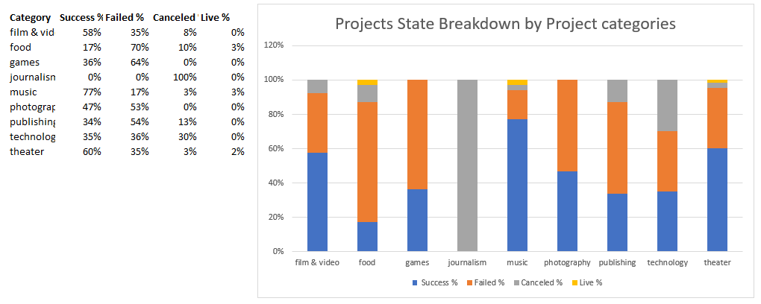

1. As shown in the below graph and based on given data, the most successfully launched projects between 2009 and 2017 were created with less than a 1,000 goal. Incredibly, %71 of the projects with goals of less than 1,000 were successfully funded. The success rate of the projects is still high with the percentage of 53 for projects less up to 9,999. However, only %20 of the projects with a goal of greater or equal 50K succeed. The success rate of the projects decreases by increasing project goals.

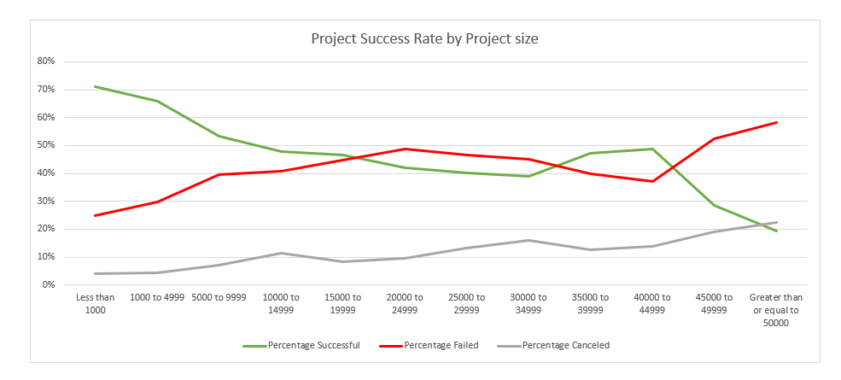

1. The given data shows that Kickstarter was active in 21 countries between 2009 and 2017. The United States has significantly high number of 3038 projects launched between 2009 and 2017, followed by Great Britain with 604 projects and Canada with 146 projects.

### 2. What are some limitations of this dataset What are some limitations of this dataset?

* Only 4114 out of 300,000 projects included in the data set. Therefore, it may not accurately represent all Kickstarter campaigns.
* Definition of success and failed states are not defined.
* The goal and pledged amounts are in different currencies. Any amount comparisons will be misleading without making any conversion.

### 3. What are some other possible tables and/or graphs that we could create?

* Average goal and average pledge per country
* Average backpackers per country
* Project counts per year
* Project state ratio per year
* Average project duration report
* Monthly project trend report
* Monthly project state report